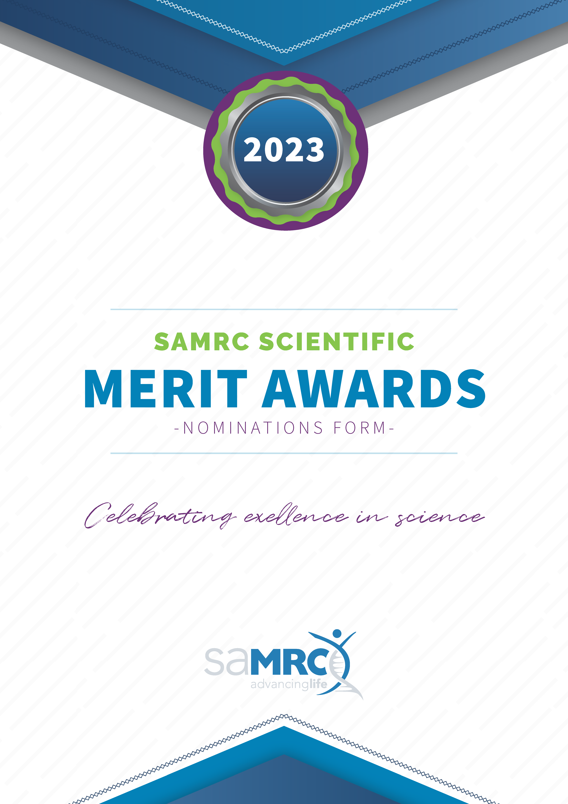

NOMINATION FORM
Please read the section on Medal Types & Procedures before completing this form.
For queries - write an email to: awards@mrc.ac.za.
Please ensure that the forms are completed in full as incomplete submissions will not be considered. Note that only the last page must be signed and dated by both the nominee and the nominator and may be submitted as a pdf (while the Division secures submitted information, you may submit this page as a pdf for security purposes).
The full application may not exceed 10 pages (excluding the cover page, CV and copy of identity document).
Completed forms should be submitted in MS Word format to: awards@mrc.ac.za on or before the submission deadline.
Please attach the Nominee’s
- Full CV
- Copy of Identity document or passport
Total of 11 pages including cover (pdf or Word file).

The deadline for submission of completed nomination forms is
30 September 2023

Please contact awards@mrc.ac.za if you do not receive acknowledgement of receipt of your nomination from the SAMRC within two weeks of submitting.
Category in which the nomination is being made (please tick):
Platinum (Lifetime Achievement Award)

Gold (Scientific Achievement Award)

Silver (Early/Mid-Career Scientist Award)

Bronze Medal (Promising Emerging Researcher Award)

Details of the Nominee
(Complete this section with the details of the individual being nominated for the award)
Title:
Surname:
First Name:
All other given names:
Current position/s:
Institution:
Research area/niche:
Gender:
Age:
Date of birth: | Year: | Month: | Date:
Country of citizenship:
Physical Address:
Postal Address:
Highest Qualification/s:
Year of Qualification:
NRF Rating:
Telephone number:
Fax number:
Email:
Details of the Nominator
(Complete this section with the details of the person making the nomination)
Title and Full Name:
Current position/s:
Institution:
Physical Address:
Postal Address:
Telephone number:
Fax number:
Email:

Motivation for the Award
In a maximum of 1000 words overall for the three subheadings (A,B,C) summarise the nominee’s contributions relevant to the award category and why they should be considered. Include a short description of the nominee’s achievements or contributions that have had impact on the health of people or medical research, any exceptional breakthroughs or scientific advancements, examples of national and international acknowledgements of the nominee’s research achievements, and a summary of the nominee’s research output in general. Add rows to the tables if necessary.
A | Achievements/Contributions  List ‘distinct’ achievements /contributions with impact on health | Brief description of the impact on health of people or health research
1.
2.
3.
4.

B | Exceptional breakthroughs  List of exceptional breakthroughs or scientific achievements | Brief description of impact on health of people or health research
1.
2.

C | Acknowledgements  List national and international acknowledgements of achievements | Brief description of acknowledgements
National
1.
2.
3.
International
1.
2.
3.

Other Awards received by the Nominee
Please list any other national and international awards received by the nominee.
 | Name of Award | National | International | Awarding body | Year
1.
2.
3.
4.

Research Output of the Nominee
Please list the nominee’s 20 most important research outputs (in bibliographic format) (publications, books, patents, or products can be included here). For journal publications, please indicate the journal Impact Factor and number of Times Cited to date.
Complete Reference in bibliographic format |  | IF | Number of Citations
1.
2.
3.
4.

5.
6.
7.
8.
9.
10.
11.
12.
13.
14.
15.
16.
17.
18.
19.
20.
Please provide the h-indexes for the nominee:
(You may request your university library to assist you)
H-index Verification | Score | Relevant link and Date drawn
Web of science h-index
Scopus h-index
Google h-index

Commendable appointments of the Nominee
Please list any relevant appointments of the nominee to serve on national and international panels, advisory groups and working groups in their field of research. Also list membership of scientific academies.
No. | Panels and other groups | National/  International | Term (duration)
1.
2.
3.
4.
5.
6.
7.

List Other Contributions of the Nominee to Health Research
Please mention any additional contributions (not discussed or listed in any other section) to health research made by the Nominee in general that may be relevant to the award.
No. | Contribution
1.
2.
3.
4.
5.

Contribution to Capacity Development
List the nominee’s contribution to research capacity development, with special emphasis on the promotion of doctoral degrees (PhD) and student race and gender diversity in the health sciences.

Contribution to diversity and gender equity
Please provide an overview of the profile of the PhD graduates that the nominee supervised.
Profile of PhD graduates | Total
Female
Male
African
Coloured
Indian
White

Details of PhD Graduates
(Insert additional rows in the table if necessary)
No. | Name of graduate | Abridged title of thesis | Institution | Year of graduation | Race | Gender | Disability
1.
2.
3.

Referees (optional)
The inclusion of referee names is optional

Referee 1
Title and Full Name:
Position:
Institution:
Physical Address:
Postal Address:
Telephone number:
Email:
Website (if applicable):

Referee 2
Title and Full Name:
Position:
Institution:
Physical Address:
Postal Address:
Telephone number:
Email:
Website (if applicable):

Referee 3
Title and Full Name:
Position:
Institution:
Physical Address:
Postal Address:
Telephone number:
Email:
Website (if applicable):

Declaration by Nominator and Nominee
I, …………………….. (nominator) hereby nominate ………………….. (nominee) for an SAMRC Merit Award.

Signed:

Date:

I, ................................... (nominee) hereby accept my nomination for an SAMRC Merit Award and understand the criteria and eligibility for such awards.

I also declare that all information provided above is true and accurate.

Signed:

Date: ..................................

