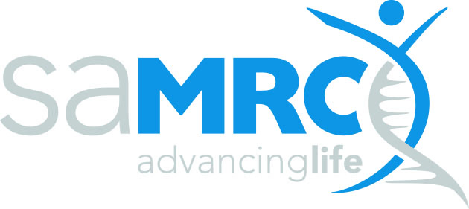 | technology transfer office

Invention Disclosure Form

Confidential

Please complete the questions as accurately and comprehensively as possible, preferably in electronic format. The text in the blue boxes has been provided as a guide to facilitate the completion of the form. Please feel free to elaborate further, if necessary. If you need assistance with completing the form, please contact the SAMRC Technology Transfer Office team at tto@mrc.ac.za.

1.) Please fill in your personal and contact details

Title
First Name
Last name
Institution
Dept./Unit/Group
Tel No.
Email

2.) Provide a brief description of the invention and how it works?

3.) What is novel about the invention?

What are the new and unusual features and benefits of the invention? What makes it different from anything else? What advantages does this invention have over existing technology (cheaper, faster, more efficient, breakthrough)? Is the invention easy for buyers to adopt?
Which of the features/benefits described could be used to help market the invention to potential licensees?

4.) Have you conducted a literature search to determine the novelty of the invention?

Cite any of your own publications, and those of others that disclose ideas most closely related to the invention. Please attach relevant publications, if available.

5.) What are the invention’s applications, uses, and markets?

What problem does it solve? Who would it likely benefit?

6.) Has any commercial interest in the invention been demonstrated?

If so, by whom? How did they become aware of the invention? What is their interest in the invention?

7.) Has the invention been described in a publication or oral presentation by you or others working with you?

For the purposes of this question, and the following question, a publication or oral presentation means:
- A thesis
- An oral presentation at any meeting
- An abstract that has been submitted or published
- A paper that has been submitted or published
- A paper presented at a conference
- A poster that has been viewed at a conference or exhibition
- News stories
- A conversation with colleagues not involved in the invention
- Discussions with industry representatives
If there has been a publication or oral presentation, specify each occasion that it has occurred. Include the date, and place, company or person involved and their contact details, and identify the meeting/journal. Provide copies of any paper, abstract, power point presentations, slides or overheads, and anything else documenting what was published or presented orally.

8.) Are you planning to publish the invention or present it orally?

Are you planning to submit a report, abstract, paper or thesis relating to this invention for publication, or for presentation at a conference or meeting, or to a research sponsor? If yes, give details, including the date of planned submission and whether the manuscript has been accepted. Please provide a copy of the proposed paper, abstract or presentation, if possible.

9.) Who are the people who have contributed to this invention?

Who are the persons that have made an inventive or other contribution to the invention? Include the person’s full name and his or her Institution or Company and Department, Unit or Group and position, i.e. PhD student, project leader etc.
If in doubt about whether a particular person is an inventor or enabler, include the person and briefly describe your views.

 | Full Name | Institution/ Company/Department/Unit/Group | Position
1 | * | * | *
2 | * | * | *
3 | * | * | *
4 | * | * | *
5 | * | * | *

[add more rows if necessary]

10.) Has the project which led to the invention been a collaborative project with another university, another research organisation, or any other organisation, including a private sector organisation?

If so, provide full particulars of the collaboration. Who were the individuals? What was the precise contribution by each collaborator? Please provide a copy of any research contracts or collaborative agreements signed with these parties.

Please return the completed form to:
SAMRC Technology Transfer Office by email:
Email: tto@mrc.ac.za

