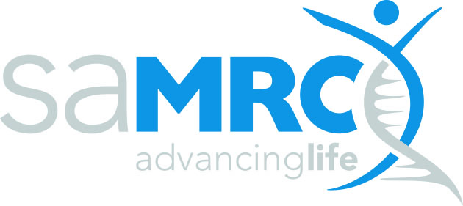 | grants, innovation and product development

SAMRC Self-Initiated Research Grants - Approval Form

Section A: Certification by applicant and research institution

I herewith declare that to the best of my knowledge:
- The work outlined in this proposal is my own original work and that the inputs, contributions, and the work of others have been appropriately acknowledged where relevant.
- I have undertaken due diligence to ensure that the work proposed has not been done elsewhere in a manner identical to or having an identical process and outcome as that which I propose to do.
- I have permission from the Head of Department/Division/Faculty to undertake the proposed work within the precincts of said entity and will have access to all required facilities and other forms of support.
- The work will be undertaken strictly according to accepted ethical and professional research practice, within the provisions and regulations of my host institution and any other applicable national or international prescriptions. I undertake to notify the SAMRC should there be a change in this status, and I accept that the SAMRC has the right to cancel or withdraw any awarded grant monies if and when there is a transgression of any law, legal and/or ethical provision/requirements governing good research practice in the execution of the proposed work.
- The information provided in this proposal is true, correct, and accurate and I understand and accept that the SAMRC reserves the right to cancel any grant awarded on the basis of false or inaccurate information.
- I accept that the SAMRC reserves the right to reject incomplete, inappropriate, or inadequate proposals/applications.
- I also acknowledge that I have read and concur with the POPIA statement contained in the Call for Applications and the SIR Proposal Template.

Full name (print)………………………………………………………………………………………………………….

ID number………………………………………………

Place……………………………………………………………………Date………………………….……………………

Institutional approval
This is to certify that this research proposal (tick applicable box)
 |  |  |  |  | Reference no., date or comment
Has been approved by the applicable research committee or authorised structure | YES |  | NO
Is hereby approved for submission to the SAMRC for funding | YES |  | NO
Name of authorising official
Designation of authorising official
Signature of authorising official
Date of authorisation
Place

