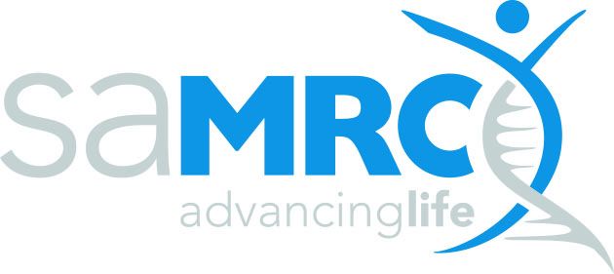 | RESEARCH CAPACITY DEVELOPMENT (RCD)
SAMRC EARLY INVESTIGATORS PROGRAMME
REQUEST FOR APPLICATION: MILESTONE TABLE
Issue date:  16 October 2024 | Closing date:  20 September 2024

Research Project details (as per the application form)

University
Applicant (PI)
Project title

Milestones
Please complete the table below (add additional rows as needed) and upload it as an attachment when submitting your application. Please include scientific deliverables here and not publications, presentations or capacity development.

Year 1
Milestone 1: (Include a short description/title of the milestone here)
Key Tasks | Duration (Start-End Date) | Deliverable(s)
Milestone 2: (Include a short description/title of the milestone here)
Key Tasks | Duration (Start-End Date) | Deliverable(s)
Milestone 3: (Include a short description/title of the milestone here)
Key Tasks | Duration (Start-End Date) | Deliverable(s)

Year 2
Milestone 1: (Include a short description/title of the milestone here)
Key Tasks | Duration (Start-End Date) | Deliverable(s)
Milestone 2: (Include a short description/title of the milestone here)
Key Tasks | Duration (Start-End Date) | Deliverable(s)
Milestone 3: (Include a short description/title of the milestone here)
Key Tasks | Duration (Start-End Date) | Deliverable(s)*

Year 3
Milestone 1: (Include a short description/title of the milestone here)
Key Tasks | Duration (Start-End Date) | Deliverable(s)
Milestone 2: (Include a short description/title of the milestone here)
Key Tasks | Duration (Start-End Date) | Deliverable(s)
Milestone 3: (Include a short description/title of the milestone here)
Key Tasks | Duration (Start-End Date) | Deliverable(s)

