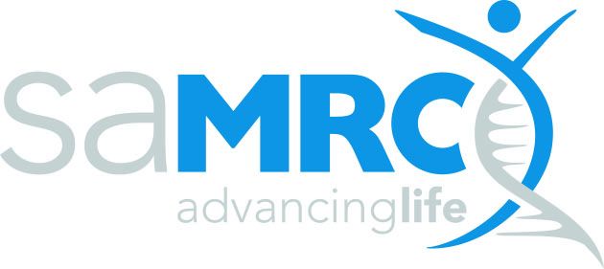 | RESEARCH CAPACITY DEVELOPMENT (RCD)

SAMRC EARLY INVESTIGATORS PROGRAMME
REQUEST FOR APPLICATIONS (RFA) 2024-Budget Form
Issue date:  16 August 2024 | Closing date:  20 September 2024

Item | Year 1 | Year 2 | Year 3 | Total Amount requested from the MRC
- Running Cost
- Consumables
- Materials, and supplies
- Laboratory including reagents, kits disposable labware /field costs
- Patient participation cost
- Office supplies, printing & photocopies, data, sim cards, telephone cost
Sub Total
- Personnel cost
- Salary top-up of the PI
- Research Assistants (up to 15 % of the running cost)
- Field workers
- Consultants (only allowed after motivation, up to 10% of the running cost)
Sub Total
- Publication cost
(if not covered by university)
- Research travel
(Cost estimation per km as allowable per institution). This is not for conference
- Travel to sites
- Participant /patient transport
- Other, specify
Sub Total
- Minor Equipment Cost
(up to 5% of the total grant)
- Conferences and Workshops (Cost of accommodation and living expenses to be covered by the hosting institution)
- Local Conferences
Travel
- International Conferences
Travel
- Workshops
Travel
Sub Total
Overheads (up to 5%)
VAT 15%
TOTAL

