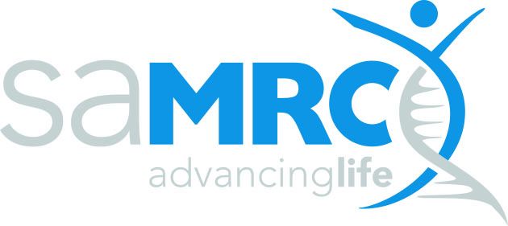 | 

Mpox Research in South Africa

Name of Applicant: __________________________________
Project Title: _______________________________________
Name of Institution: _______________________________________

Certification by Applicant
I herewith declare that to the best of my knowledge

- the work outlined in this proposal is my own original work and that the inputs, contributions and the work of others have been appropriately acknowledged where relevant;
- all co-investigators and collaborators listed in the proposal are aware of this proposal and have agreed to their inclusion herein;
- I have undertaken due diligence to ensure that the work proposed has not been done elsewhere in a manner identical to or having an identical process and outcome as that which I propose to do;
- I have permission from the Department/Division/Directorate/Faculty to undertake the proposed work within the precincts of said entity and will have access to all required facilities and other forms of support;
- the work will be undertaken strictly according to accepted ethical and professional research practice, within the provisions and regulations of my host institution and any other applicable national or international prescriptions;
- the information provided in this proposal is true, correct and accurate and I understand and accept that the SAMRC reserves the right to cancel any grant awarded on the basis of false or inaccurate information;

I accept that the SAMRC reserves the right to reject incomplete, inappropriate or inadequate proposals/applications.

I acknowledge and agree to the sharing and use by the SAMRC of my personal information provided in this proposal for the purpose of evaluating the research proposal for funding as set forth in the RFA document.

Full name of principal investigator (print)…………………………………………………………………………………………

Signature………………………………………………………… Date……………….……………………

Institutional approval
This is to certify that this research proposal (tick applicable box)

 |  |  |  | Reference no., date or comment
Project has been approved by the applicable research committee or authorized structure |  | YES | NO
Proposal is hereby approved for submission to the SAMRC for funding |  | YES | NO
Name of authorizing official
Designation of authorizing official
Signature of authorizing official (Electronic signature allowed)
Date of authorization

