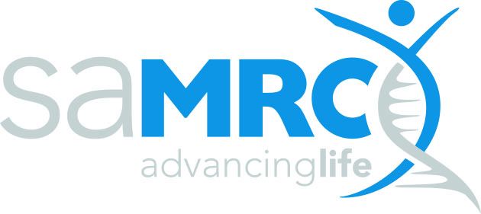 | grants innovation and product development
Support for the South African National Health Research Enterprise
in Response to U.S. Funding Withdrawals
SAMRC-RFA-GIPD-04-2025

SAMRC ABRIDGED PROPOSAL

SECTION 1: Summary Information

Project Title
Original U.S. funding agency
Month & Year of 1st award
Duration of original award
Date of most recent NOA
Project Stage | Indicate which year of the project: 1st, 2nd etc.
Requested Funding (in ZAR) | Insert total budget amount
Intended Start | Month and year
Intended Duration | x months
Lead Principal Investigator (Main Applicant)
Title, First Name, Surname
ID Number
Institution
Institution Address
PI e-mail Address
PI Telephone Number
PI Gender | Male / Female / Other
PI Ethnic Group | African / Coloured / Indian / White / Other (please specify)
*Co-applicant(s) / Co-investigator(s)
Title, First Name, Surname
Institution
Gender | Male / Female / Other
Ethnic Group | African / Coloured / Indian / White / Other (please specify)
*Note that Co-applicants/Co-investigators are investigators that are also applying for funding from the SAMRC as part of this application.

Research area (select all applicable):
Thematic area | Select | Specify
TB
HIV
Maternal, Newborn and Child Health
Non-Communicable diseases
Other infectious diseases
Other
Proposal must be no more than 10 pages, including this title page.

SECTION 2: Project Details

2.1 Background and overview of the original U.S. funded project and funding status (e.g. has it been terminated, paused, reinstated and when)

2.2 Impact of the U.S. funding cuts on the project / personnel /unit /organisation/ research participants

2.3 Other resources leveraged to date to address the funding withdrawal / pause

2.4 Summary of work to be funded under this RFA as interim relief

2.4.1 Milestones and Deliverables to be funded under this RFA as interim relief

Milestone 1: (Include a short description/title of the milestone here)
Key Tasks | Duration (Start-End Date) | Deliverable(s)*
Milestone 2: (Include a short description/title of the milestone here)
Key Tasks | Duration (Start-End Date) | Deliverable(s)*
Milestone 3: (Include a short description/title of the milestone here)
Key Tasks | Duration (Start-End Date) | Deliverable(s)*
*Please include scientific/product development deliverables here and not publications, presentations or personnel capacity development

2.5 Significance of the research and the potential impact on the South African health system, research capacity and advancement of the field

2.6 How this grant will be leveraged for future sustainability of the project/personnel /unit/organisation beyond the duration of the interim funds

SECTION 3: Funding

3.1 Summary Budget
Please provide a detailed budget for the principal investigator and co-investigator in the excel budget template provided. Budget must be exclusive of VAT.
You may amend the budget line items in line with your original U.S. budget.
(Include only summary information for the funding request from the excel document in the table below)

Budget Item | Year 1 current request  (ZAR) | Year 1 current request (USD) | Original U.S. budget (USD)
Total Direct Costs
Indirect Costs (X%)
Total Costs for the Period

3.2 Detailed Budget justification
(Please provide a detailed budget justification for all the budgeted items included)

3.3 Funds Requested and/or Received
(Please provide details of any other funding applied for and/or received for this project or parts thereof, including the name of the funding agency and amounts awarded and received to date. Also include details of support provided by your own institution, if any.)

3.4 SAMRC Associations and Funding
(Please provide details of any direct affiliations or associations [excluding research collaborations] you have with the SAMRC, including positions on the SAMRC Board or other committees, as well as other grants from the SAMRC currently held)

SECTION 4: Certification by Applicant and Organisation
I herewith declare that to the best of my knowledge:

- the work outlined in this proposal is directly in line with my original approved U.S.-funded grant;
- the work outlined in this proposal has not already received funding other than as listed in the proposal;
- the work outlined in this proposal is my own original work and that the inputs, contributions and the work of others have been appropriately acknowledged where relevant;
- all co-investigators and collaborators listed in the proposal and the original U.S.-funded proposal attached as supporting document are aware of this proposal and have agreed to their inclusion herein;
- I have undertaken due diligence to ensure that the work proposed has not been done elsewhere in a manner identical to or having an identical process and outcome as that which I propose to do;
- I have permission from the Department/Division/Directorate/Faculty to undertake the proposed work within the precincts of said entity and will have access to all required facilities and other forms of support;
- the work will be undertaken strictly according to accepted ethical and professional research practice, within the provisions and regulations of my host institution and any other applicable national or international prescriptions;
- the information provided in this proposal is true, correct and accurate and I understand and accept that the SAMRC reserves the right to cancel any grant awarded on the basis of false or inaccurate information.

I accept that the SAMRC reserves the right to reject incomplete, inappropriate or inadequate proposals.
I accept and agree to the SAMRC’s use of my personal information included in this application for the purposes of processing, evaluating and making decisions on my application, including sharing of this information with local and international reviewers, where applicable, local and international funders and the SAMRC management on a confidential basis, and the publication of my name, institution and non-confidential project details.

Full name (print)……………………………………………………………………………………………………………………..

Signature………………………………………………………… Date……………….……………………

Institutional approval
This is to certify that this research proposal (tick applicable box)

 |  |  |  | Reference no., date or comment
Has been approved by the applicable research committee or authorized structure |  | YES | NO
Is hereby approved for submission to the SAMRC for funding |  | YES | NO
Name of authorizing official
Designation of authorizing official
Signature of authorizing official
Date of authorization

