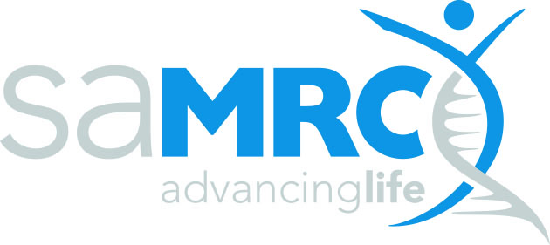 | RESEARCH CAPACITY DEVELOPMENT (RCD)

SAMRC MID-CAREER SCIENTIST PROGRAMME
APPLICATION- MILESTONE TABLE

Research Project details (as per the expression of interest form)

University
Applicant (PI)
Project title

Milestones
Please complete the table below (add additional rows as needed) and upload as an attachment when submitting your application. Please include scientific deliverables here and not publications, presentations or capacity development.

Year 1
Milestone 1: (Include a short description/title of the milestone here)
Key Tasks | Duration (Start-End Date) | Deliverable(s)*
Milestone 2: (Include a short description/title of the milestone here)
Key Tasks | Duration (Start-End Date) | Deliverable(s)*
Milestone 3: (Include a short description/title of the milestone here)
Key Tasks | Duration (Start-End Date) | Deliverable(s)*

Year 2
Milestone 1: (Include a short description/title of the milestone here)
Key Tasks | Duration (Start-End Date) | Deliverable(s)*
Milestone 2: (Include a short description/title of the milestone here)
Key Tasks | Duration (Start-End Date) | Deliverable(s)*
Milestone 3: (Include a short description/title of the milestone here)
Key Tasks | Duration (Start-End Date) | Deliverable(s)*

Year 3
Milestone 1: (Include a short description/title of the milestone here)
Key Tasks | Duration (Start-End Date) | Deliverable(s)*
Milestone 2: (Include a short description/title of the milestone here)
Key Tasks | Duration (Start-End Date) | Deliverable(s)*
Milestone 3: (Include a short description/title of the milestone here)
Key Tasks | Duration (Start-End Date) | Deliverable(s)*

