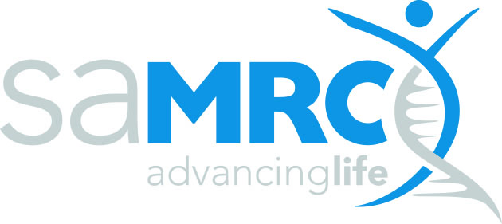 | RESEARCH CAPACITY DEVELOPMENT (RCD)

SAMRC MID-CAREER SCIENTIST PROGRAMME
APPLICATION- 2025-Budget Form

Item | Year 1 | Year 2 | Year 3 | Total Amount requested from the MRC
- Running Cost
Consumables
- Materials, and supplies
- Laboratory including reagents, kits disposable labware /field costs
- Patient participation cost
- Office supplies, printing & photocopies, data, sim cards, telephone cost
Sub Total
- Personnel cost
- Research Assistants
- Field workers
- Consultants (only allowed with motivation)
Sub Total
- Publication cost (if not covered by university)
- Research travel
- Travel to sites
- Participant /patient transport
- Other, specify
Sub Total
- Minor Equipment Cost
- Conferences and Workshops
- Local Conferences
Travel
Accommodation
Living expenses
- International Conferences
Travel
Accommodation
Living expenses
- Workshops
Travel
Accommodation
Living expenses
Sub Total
Overheads (not more than 5%)
VAT 15%
TOTAL

NOTE ON THE BUDGET
- Value of the award
This grant amounts to a maximum of R1 250 000.00 p.a. in the first year of funding and a maximum not exceeding R1 500 000.00 in the second year of funding. This funding is renewable for a further three years (R1 500 000.00 p.a.) on condition of satisfactory progress and availability of funds.
- Conditions
The grant cannot be used for any other purposes without written approval from the SAMRC. Funding for this initiative in the first year is structured thus: R1 000 000.00 is towards the salary budget of the sub-specialist on the project. Research costs up to R250 000.00 will be funded. The research programme must demonstrate an intentional and measurable contribution to the objectives of the SAMRC Mid-Career Scientist programme.

